DEPARTMENT OF CHEMISTRY

- OVERVIEW OF THE DEPARTMENT :
The department of chemistry was established in 2022 and has been committed to excellence in teaching and research. It provides a strong foundation in theoretical and experimental chemistry.
- VISION :
“ To be a leading hub for advanced learning and research in chemistry ”.

- MISSION :
- To deliver quality education in chemistry.
- Promote innovative research and faster scientific curiosity.
- Ethical responsibility among students.

- COURSES OFFERED :
- B.Sc [BZC] [Botany, Zoology, Chemistry]
- B.Sc [MPC] [Mathematics, physics, chemistry]

- FACULTY :

NAME | QUALIFICATION | DESIGNATION | SPECIALIZATION
E. Anusha | M.Sc [ Organic chemistry] | Guest Lecturer [2022-24] | Organic chemistry
A.Aruna kumari | M.Sc [Organic chemistry] TS-SET | Degree lecturer[2024-25] | Organic chemistry
SRIVANI BOYA | M.Sc [Organic chemistry] CSIR-UGC-NET & AP-SET | Degree lecturer [2024-till now] | Organic chemistry

- SRIVANI BOYA M.Sc. CSIR-UGC-NET, AP-SET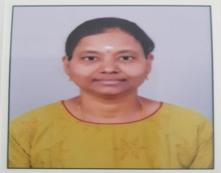

- EDUCATIONAL QUALIFICATION :
- She has completed for M.Sc chemistry with organic chemistry specialization in 2009 from MNR PG college Hyderabad affiliated to Osmania University.
- She has qualified lectureship [NET] in 2012 conducted by joint CSIR-UGC test in the subject chemical sciences.
- She has qualified AP-SET in 2012 conducted by Osmania University in the subject Chemical sciences.

- TEACHING EXPERIENCES :
- She worked as a lecturer in MNR PG college Hyderabad for 2013 to 2015.
- She worked as a guest lecturer in Dr. BRR Govt Degree college [Accrediated with B++ by NAAC] for 2010 to 2012- January

- INFRASTRUCTURE :
- Well experienced faculty.
- Smart class rooms .

- DEPARTMENT ACHIEVEMENTS :
- Attended one day National seminar “The Role of Spectroscopy in Characterization of Small Molecules [ SCSM-2024]” 25th ,October , 2024 conducted by [RSC] Royal Society of Chemistry, London –U.K at Pingle Government college for women [Atonomy] , Hanamkonda, TS.
- BZC -1ST Year students got 1st prize in poster presentation.
- From our department chemistry students including 1st ,2nd & 3rd Year students given poster presentation on 25th October , 2024 conducted by [RSC] Royal Society of Chemistry , London – U.K at pingle Government college for women [A], Hanamkonda, TS.

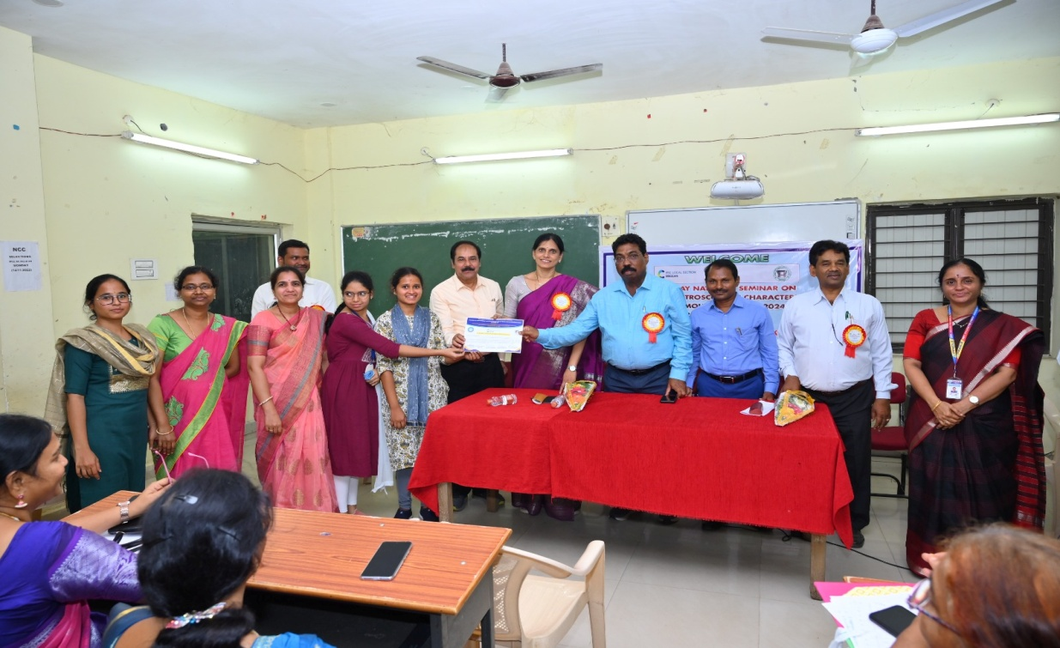
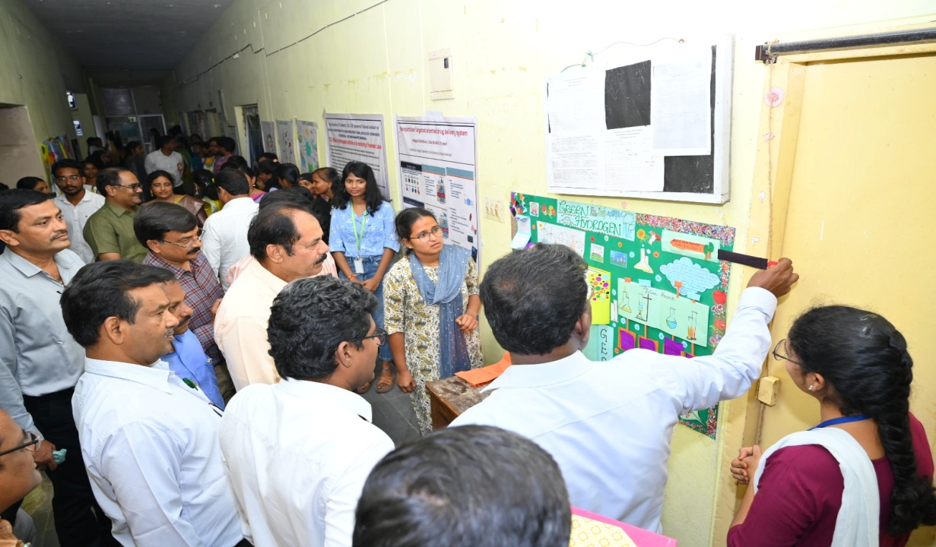

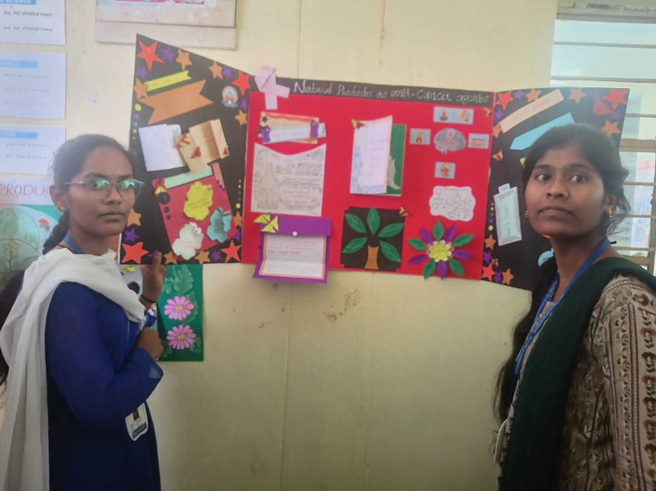

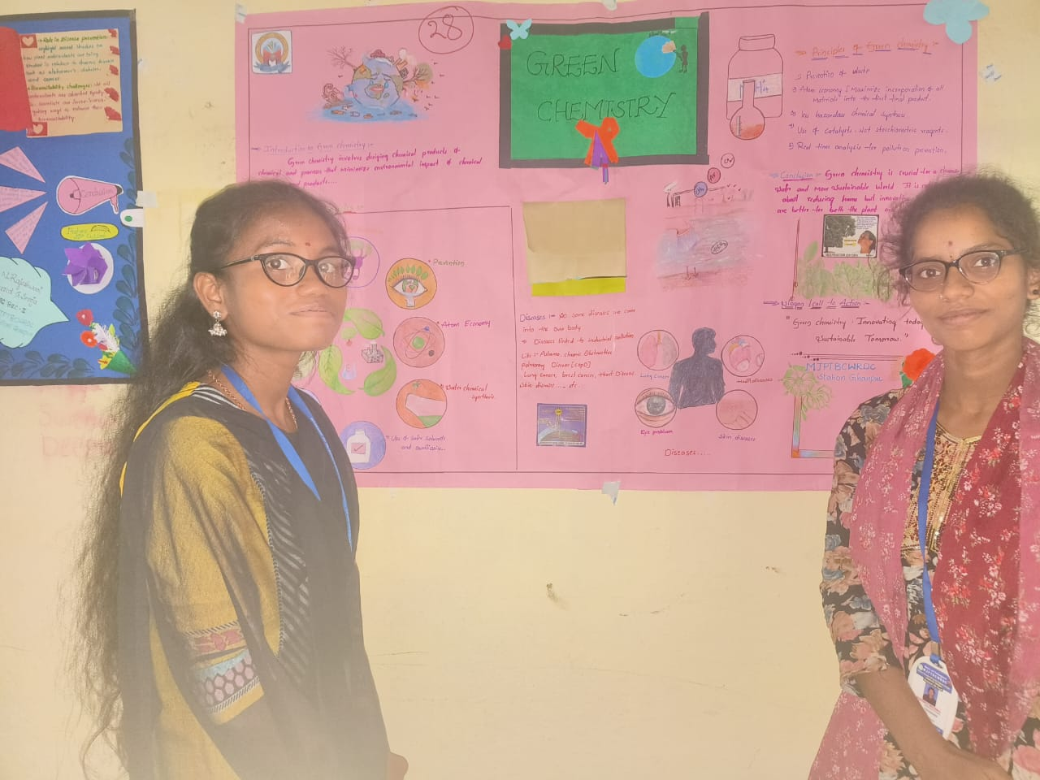
- Srivani
- ACTIVITIES :
- Department of Chemistry conducted student seminars.
- PPT & Poster presentation done by students.
- Participated in National Science day.

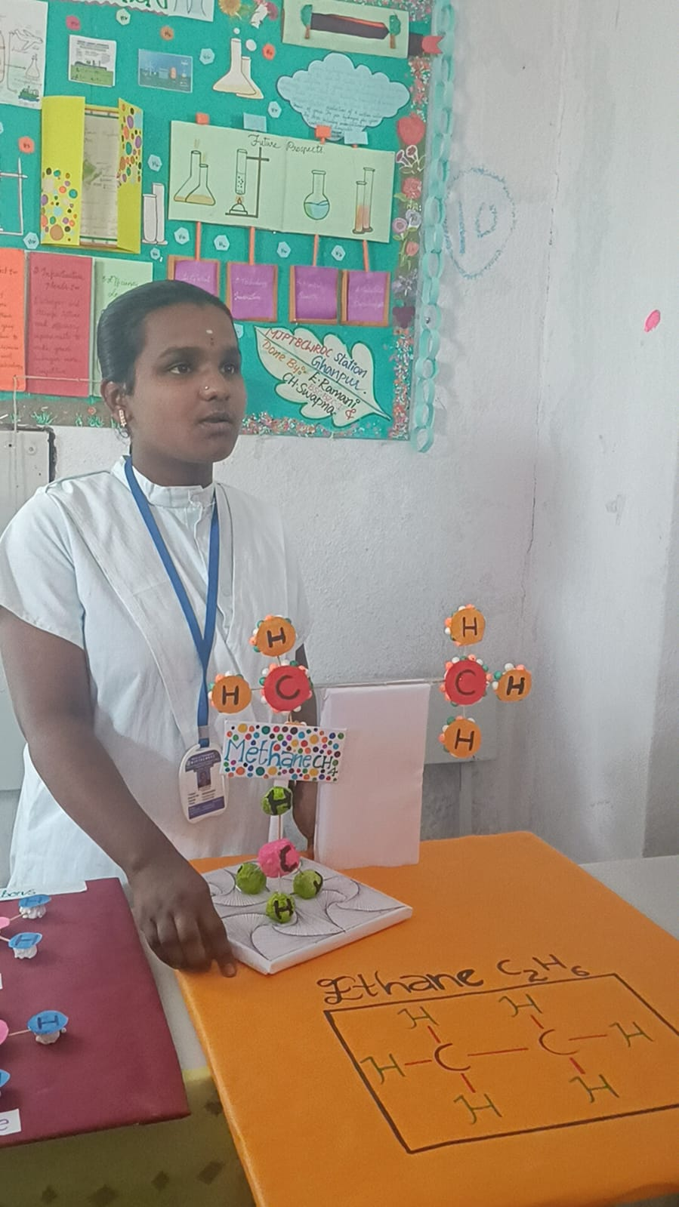
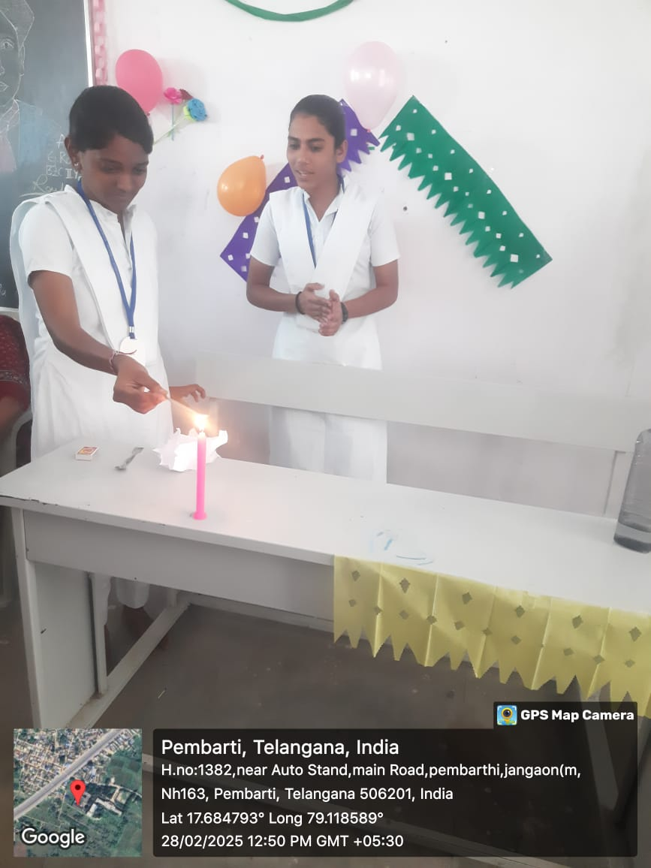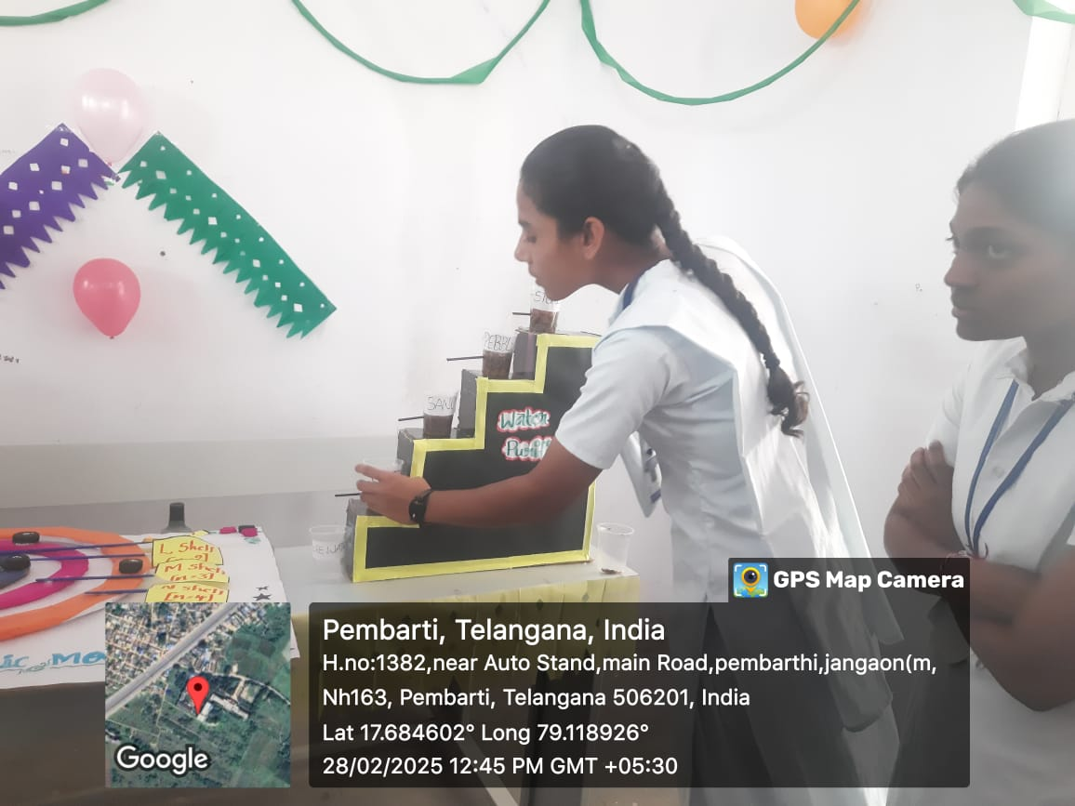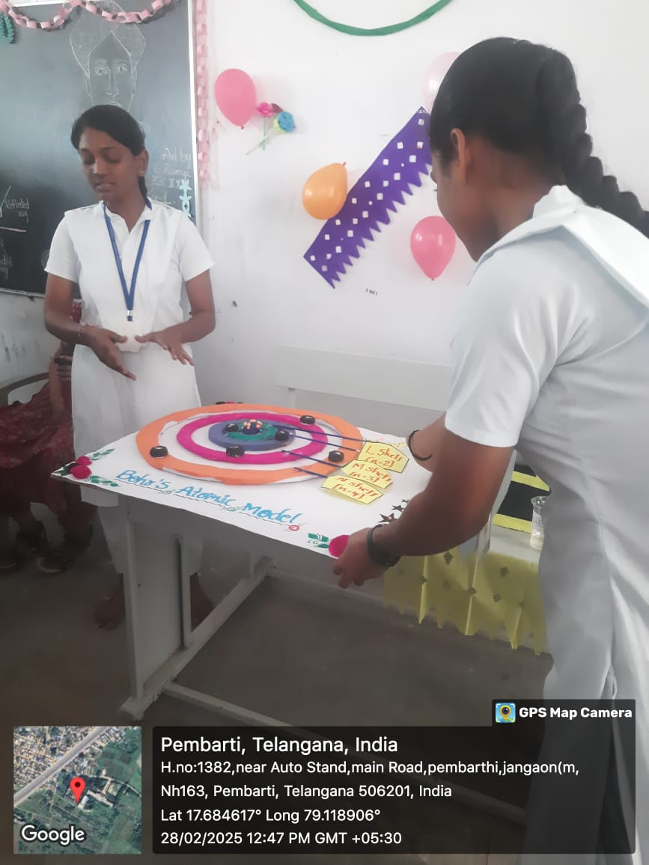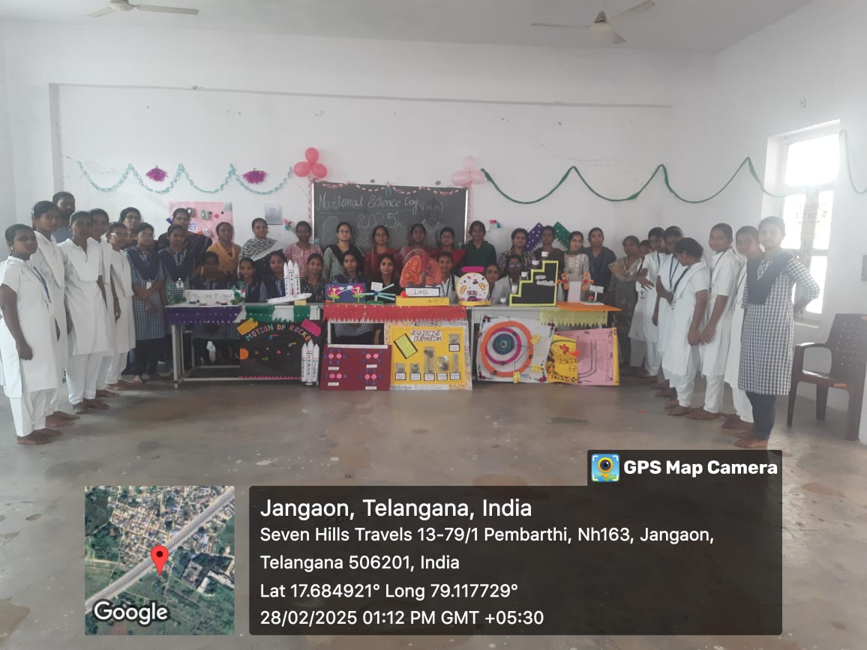
- Srivani Boya DL- Chemistry has successfully Attended Chemistry Webinar on “ SYNTHESIS, CHARACTERIZATION AND BIOLOGICAL APPLICATIINS OF Pd (II) COMPLEXES” as a part of National Seminar / Webinar on “ Multi Disciplinary Approaches in Sciences on 05th & 06th March -2026 Conducted by Telangana govt. tribal Welfare Residential Degree College for Women., suryapet.
- SRIVANI BOYA ; DL-CHEMISTRY has actively particiated in the National webinar on Advanced Research Methods in DRUG DISCOVERY held on 19th February -2026, conducted by Telangana tribal Welfare Residential Degree College ( Girls ) Jangaon
- SRIVANI BOYA ; DL- CHEMISTRY has participated in the Five days FACULTY DEVELOPMENT PROGRAMME ( FDP) On “ GREEN AND SUSTAINABLE CHEMISTRY -INNOVATIONS IN TEACHING AND LABORATORY PRACTICES “ Sponsored by PM-USHA- RUSA 2.0 GOVT.OF TELANGANA AND Conducted by DEPARTMENT OF CHEMISTRY , UNIVESITY OF ART’S AND SCIENCE COLLEGE (ATONOMOUS), KAKATIYA UNIVERSITY , SUBEDARI, HANUMKONDA From 09th to 13 th March -2026

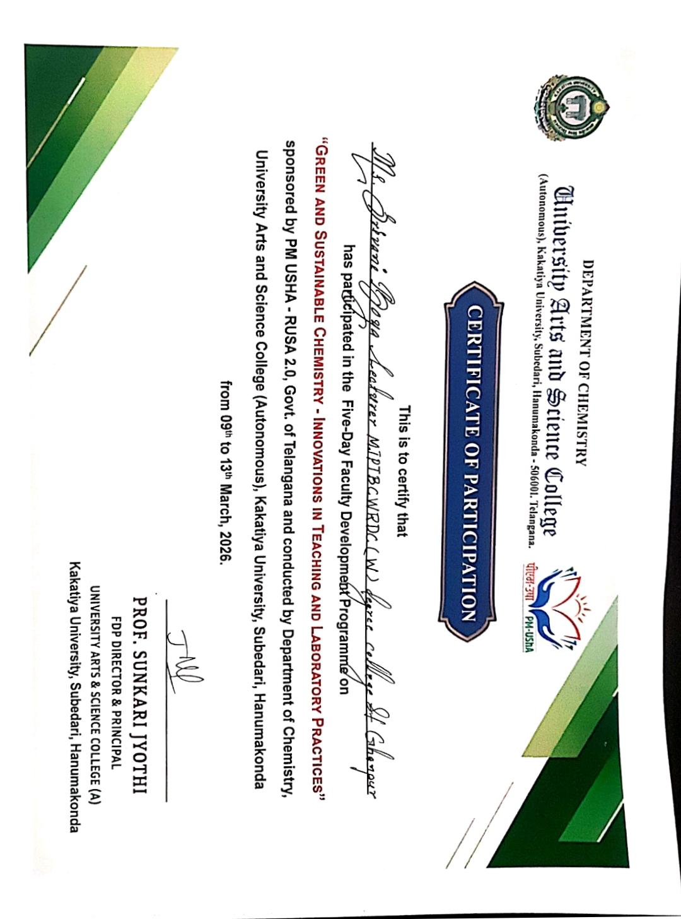
- FUTURE PLANS :
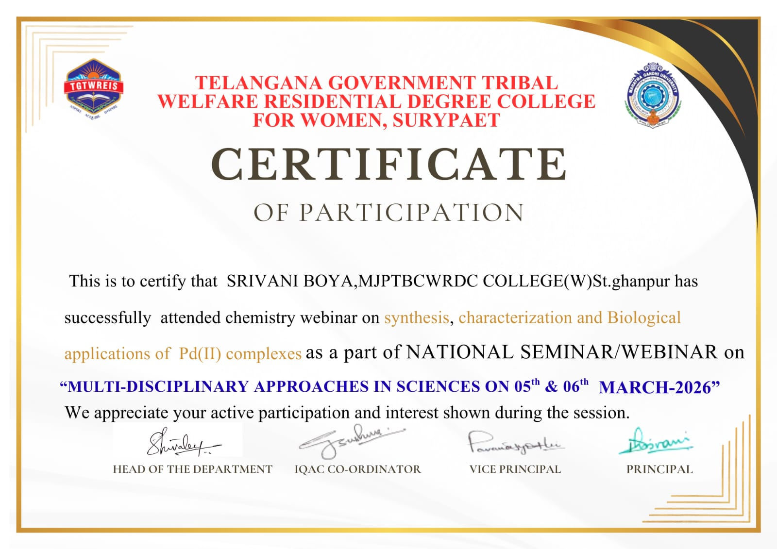
- Establishment of a Research centre.
- Introduction of Industry- collaborative courses.
- Promote student research.
- Strengthen alumni network.

RESULT ANALYSIS [2022 – 2023]

Group | year | Semester | Appeared | Passed | Failed | Pass%
B.SC[BZC] | 1 | I | 40 | 30 | 10 | 75%
B.SC[BZC] | 1 | II | 39 | 33 | 6 | 85%
 |  | TOTAL | 79 | 63 | 16 | 80%

RESULT ANALYSIS [2023-2024]

Group | Year | Semester | Appeared | Passed | Failed | Pass%
B.SC[BZC] | 1 | I | 31 | 18 | 13 | 58%
B.SC[BZC] | 1 | II | 29 | 28 | 1 | 97%
B.SC[BZC] | 2 | III | 31 | 23 | 8 | 74%
B.SC[BZC] | 2 | IV | 30 | 28 | 2 | 93%
 |  | TOTAL | 121 | 97 | 24 | 80%

RESULT ANALYSIS [2024-2025]

Group | Year | Semester | Appeared | Passed | Failed | Pass%
B.SC[BZC] | 1 | I | 16 | 13 | 3 | 81.25%
B.SC[BZC] | 1 | II | 16 | 16 | Nill | 100%
B.SC[BZC] | 2 | III | 28 | 23 | 5 | 82%
B.SC[BZC] | 2 | IV | 27 | 27 | Nill | 100%
B.SC[BZC] | 3 | V | 31 | 30 | 1 | 97%
B.SC[BZC] | 3 | VI | 31 | 29 | 2 | 93.54%
 |  | TOTAL | 149 | 138 | 11 | 93%

RESULT ANALYSIS [2025-2026]
Group | Year | Semester | Appeared | Passed | Failed | Pass%
B.SC[BZC] | 3 | V | 25 | 25 | Nill | 100%
B.SC[BZC] | 2 | III | 14 | 14 | Nill | 100%
B.SC[BZC] | 1 | I | 32 | 26 | 6 | 81.20%
 |  | TOTAL | 71 | 65 | 6 | 92%

RESULT. ANALYSIS [2026-2027]
Group | Year | Semester | Appeared | Passed | Failed | Pass%
B.SC[BZC] | 3 | VI | 25 | 24 | 01 | 96%
B.SC[BZC] | 2 | IV | 14 | 14 | Nill | 100%
B.SC[BZC] | 1 | II | 32 | 28 | 04 | 86%
 |  | TOTAL | 71 | 66 | 05 | 93%

Student activities;
Academic year (2025-26)
- Department of chemistry conducted many activities like PPT’s and Poster presentations done by students 02/03/26 & 03/02/26 at MJP degree college St.ghanpur.
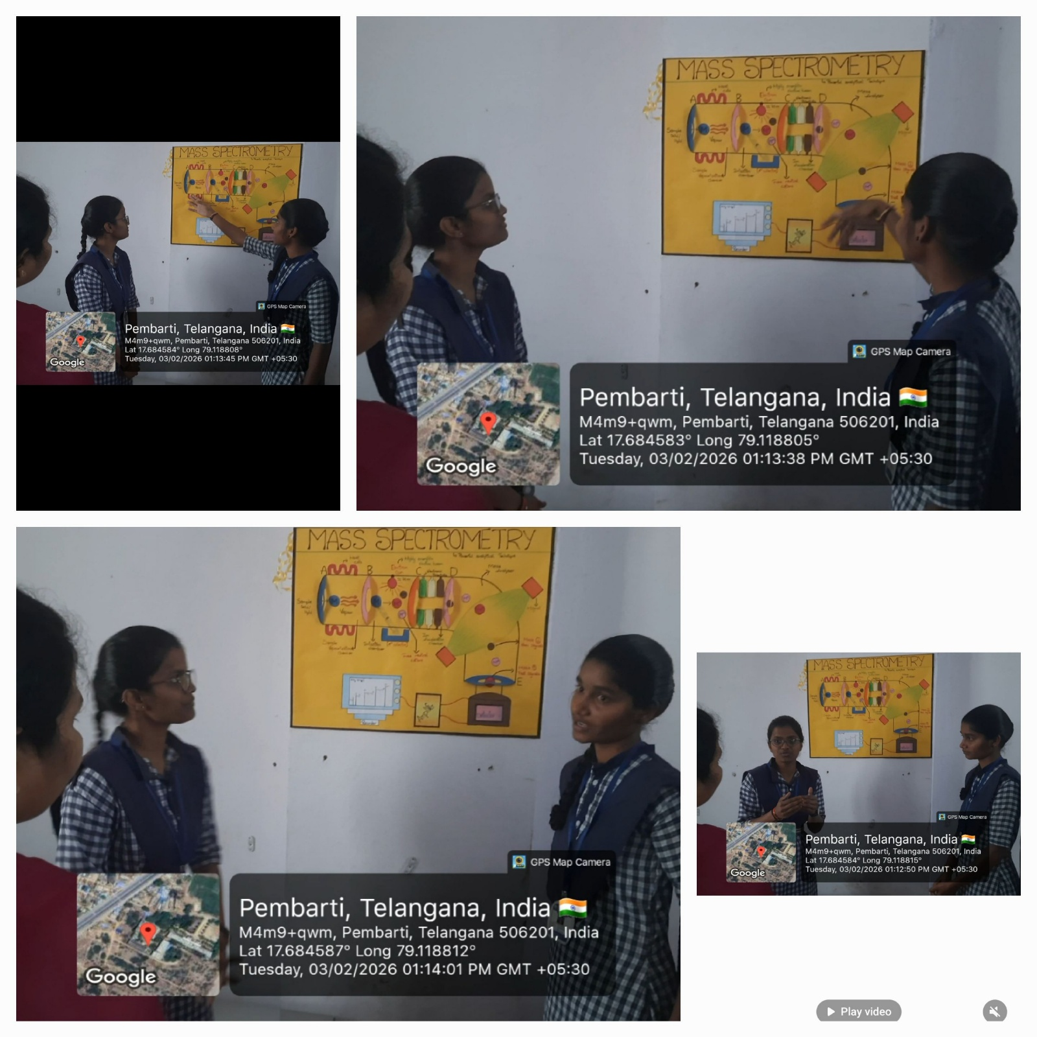

- Student’s are actively participated in Science fair in our college Feb 28th -2026

